**Tasks**

**Learners have to develop a dashboard to support the answers to the following questions.**

**Objective Questions**:

1. **What is the total no. of tables present in the data?**

Ans. Only one table is present in the dataset for analysis.

1. **What is the total no. of attributes present in the data?**

Ans. There are a total of 35 attributes in the datasheet to be cleansed and analyzed.

1. **The data consists of some inconsistent and missing values so ensure that the data used for further analysis is cleaned.**

Ans.

* Removed Irrelevant Columns with single values:
  + isWhiteListUser, queue.
* Data Cleaning and Extraction
  + createdAT: Cleaned for consistency in date and time format.
  + updatedAt: Cleaned for consistency in date and time format.
  + chatStartTime: Standardized format by extracting and normalizing date and time.
  + chatEndTime: Standardized format by extracting and normalizing date and time.
* Handling Missing Values:
  + For the chatEndTime, chatStartTime, and createdAt fields, missing values were addressed (e.g., Missing Value entries were identified).

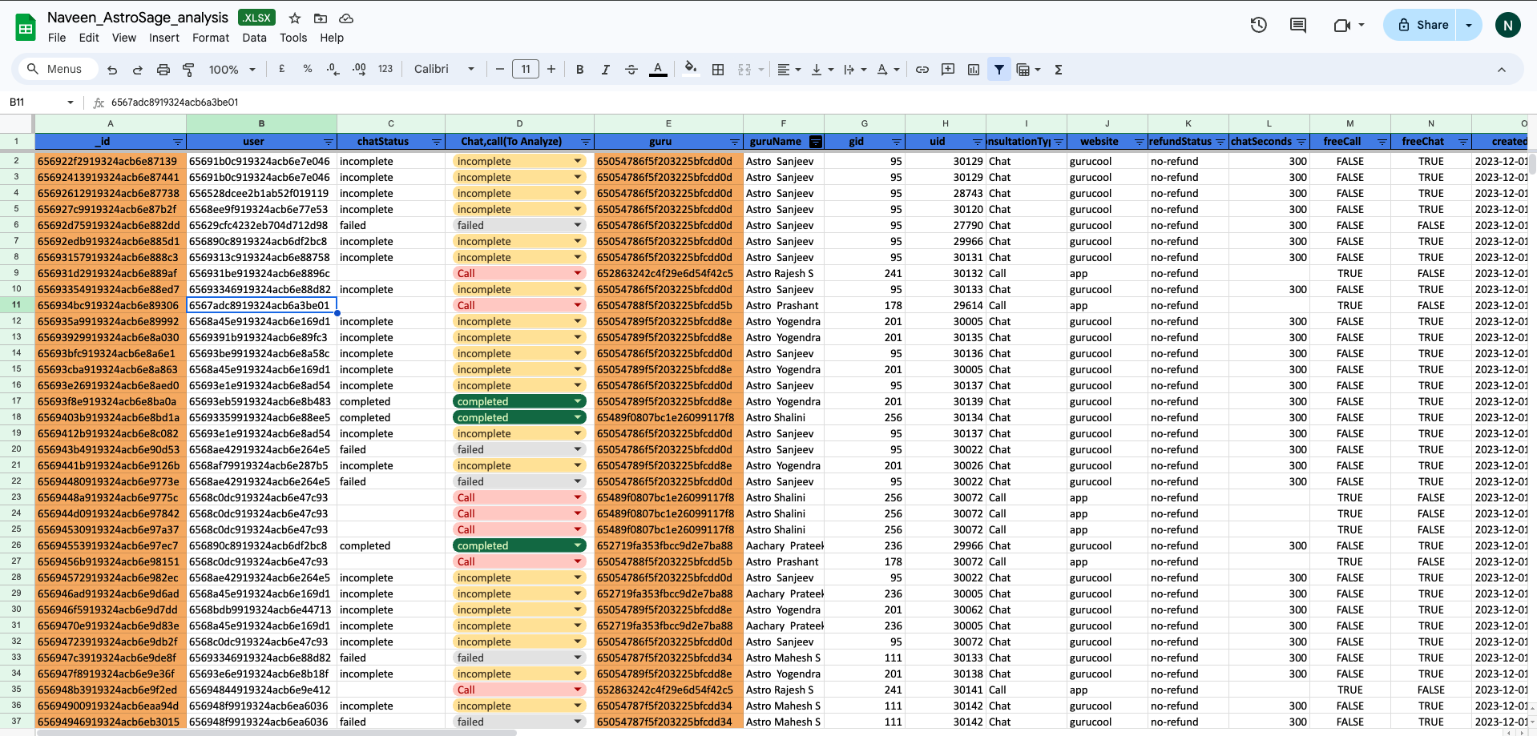

1. **What is the change in daily call volume day by day and also find the average of daily call volume?**

| *createdAt(date)* | Call volume | Day/Day change |
| --- | --- | --- |
| 01/12/2023 | 376 | N/A |
| 02/12/2023 | 335 | -41 |
| 03/12/2023 | 386 | 51 |
| 04/12/2023 | 367 | -19 |
| 05/12/2023 | 254 | -113 |
| 06/12/2023 | 255 | 1 |
| 07/12/2023 | 255 | 0 |
| 08/12/2023 | 138 | -117 |
| 09/12/2023 | 288 | 150 |
| 10/12/2023 | 431 | 143 |
| 11/12/2023 | 424 | -7 |
| 12/12/2023 | 358 | -66 |
| 13/12/2023 | 348 | -10 |
| 14/12/2023 | 226 | -122 |
| 15/12/2023 | 276 | 50 |
| 16/12/2023 | 259 | -17 |
| 17/12/2023 | 186 | -73 |
| 18/12/2023 | 234 | 48 |
| 19/12/2023 | 213 | -21 |
| 20/12/2023 | 179 | -34 |
| 21/12/2023 | 163 | -16 |
| 22/12/2023 | 166 | 3 |
| 23/12/2023 | 241 | 75 |
| 24/12/2023 | 232 | -9 |
| 25/12/2023 | 258 | 26 |
| 26/12/2023 | 255 | -3 |
| 27/12/2023 | 242 | -13 |
| 28/12/2023 | 181 | -61 |
| 29/12/2023 | 260 | 79 |
| 30/12/2023 | 179 | -81 |
| 31/12/2023 | 158 | -21 |
| 01/01/2024 | 115 | -43 |
| 02/01/2024 | 196 | 81 |
| 03/01/2024 | 107 | -89 |
| Average call per day : | 251.2058824 |  |

* Formula for average daily call volume over the day by day:

Average Daily Call Volume Day by Day==AVERAGE(B2:B35)

**Average Daily Call Volume**:

* Average = Total Calls / Number of Days
* Average = 8541/34=251.205 => 251
* Calculate Total Number of Calls Each Day:
  + Use the COUNTA function on the callStatus column to determine the total number of calls for each day.
* Insert a New Column:
  + Add a new column next to the 'Day/Day change' column.
* Calculate Day-to-Day Change:

Day/Day change =B3-B2

* + In the new column, use the formula B3 - B2 to calculate the change from one day to the next.

1. **Which months experienced the highest and lowest call volumes?**

Ans.

* **Highest Call Volume**: December 2023 recorded the highest call volume with **7,947 calls**. This suggests a significant increase in activity, potentially due to seasonal factors or specific events during that month.
* **Lowest Call Volume**: January 2024 experienced the lowest call volume, with only **418 calls**. This sharp decline following December indicates a possible post-holiday slowdown or reduced demand in the new year.
* **Total Call Volume**: The grand total of calls across the period is **8,365**, with December contributing a substantial portion of that total, indicating that the month is crucial for call activity.

| *createdAt(date) - Year* | *Month* | COUNTA of CallSid |
| --- | --- | --- |
| 2023 | December | 7947 |
| 2023 Total |  | 7947 |
| 2024 | January | 418 |
| 2024 Total |  | 418 |
| **Grand Total** |  | **8365** |

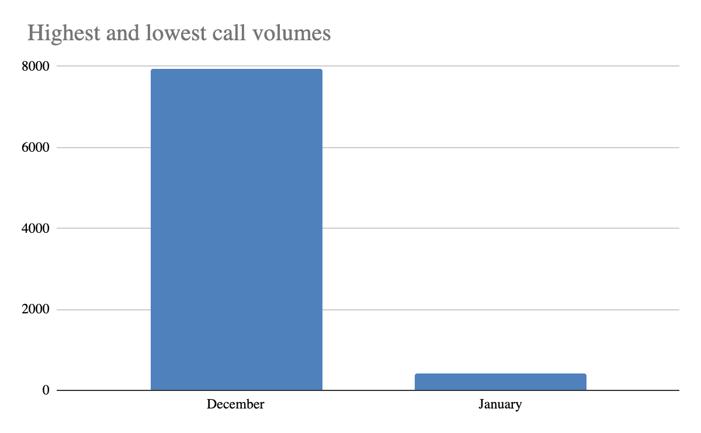

1. **What is the total operational cost for that month?**

Ans. The operational costs for both December 2023 and January 2024.

* December 2023: 202214.6253
* January 2024: 11772.69

| *Month* | SUM of netAmount |
| --- | --- |
| December | 202214.6253 |
| January | 11772.69 |
| **Grand Total** | **213987.3153** |

1. **What is the average number of calls handled per agent per day?**

Ans :The Average call handled per agent per day comes out to be 1.94

| createdAt(date) | COUNTUNIQUE of createdAt(date) | COUNTUNIQUE of guruName | COUNTA of callStatus |
| --- | --- | --- | --- |
| 01/12/2023 | 1 | 35 | 372 |
| 02/12/2023 | 1 | 37 | 333 |
| 03/12/2023 | 1 | 38 | 383 |
| 04/12/2023 | 1 | 43 | 364 |
| 05/12/2023 | 1 | 34 | 253 |
| 06/12/2023 | 1 | 32 | 254 |
| 07/12/2023 | 1 | 38 | 254 |
| 08/12/2023 | 1 | 29 | 138 |
| 09/12/2023 | 1 | 36 | 288 |
| 10/12/2023 | 1 | 44 | 430 |
| 11/12/2023 | 1 | 42 | 424 |
| 12/12/2023 | 1 | 41 | 358 |
| 13/12/2023 | 1 | 37 | 348 |
| 14/12/2023 | 1 | 34 | 226 |
| 15/12/2023 | 1 | 37 | 276 |
| 16/12/2023 | 1 | 39 | 258 |
| 17/12/2023 | 1 | 31 | 185 |
| 18/12/2023 | 1 | 38 | 233 |
| 19/12/2023 | 1 | 36 | 209 |
| 20/12/2023 | 1 | 28 | 178 |
| 21/12/2023 | 1 | 33 | 159 |
| 22/12/2023 | 1 | 23 | 163 |
| 23/12/2023 | 1 | 23 | 241 |
| 24/12/2023 | 1 | 32 | 232 |
| 25/12/2023 | 1 | 32 | 258 |
| 26/12/2023 | 1 | 22 | 255 |
| 27/12/2023 | 1 | 30 | 242 |
| 28/12/2023 | 1 | 24 | 181 |
| 29/12/2023 | 1 | 32 | 258 |
| 30/12/2023 | 1 | 24 | 179 |
| 31/12/2023 | 1 | 25 | 158 |
| 01/01/2024 | 1 | 27 | 115 |
| 02/01/2024 | 1 | 34 | 196 |
| 03/01/2024 | 1 | 27 | 107 |
| Grand Total | 34 | 129 | 8508 |

| What is the average number of calls handled per agent per day? | | | |
| --- | --- | --- | --- |
| no of unique days | no of agents | total no of calls | avg no of calls |
| 34 | 129 | 8541 | 1.947332421 |

Detailed Approach

1. Data Gathering:
   * + The total number of calls during the specified timeframe.
     + The unique days when calls were recorded.
     + The distinct agents who managed these calls.
2. Calculating Unique Counts:
   * Determine the unique number of days:
     + Use a distinct count of dates to accurately reflect the calling period.
   * Assess the unique number of agents:
     + Count distinct agent names to eliminate double counting.
3. Total Calls Assessment:
   * Sum all calls from the dataset, making sure to include all relevant call types.
4. Average Calculation:
   * **Average Calls Per Agent Per Day= Total Calls / No of days * No of agents**

Criteria for Calculation

* Data Integrity:
  + Ensure that the data used for calculations is complete, with no gaps or inaccuracies.
* Unique Counts:
  + Counts of unique days and agents should be based on distinct entries to avoid duplication.
* Consistency:
  + Verify that the reported total number of calls is consistent across various analyses, resolving any discrepancies for reliability.
* Clarity in Definitions:
  + Clearly specify what constitutes a "call" and confirm that all relevant data is included in the total count (e.g., completed,incomplete).

**conclusion:**

An average of 1.91 calls per agent per day is quite low, which could mean there are not enough users or less traffic coming in. The drop in daily call volume might signal serious problems in the business. If this trend continues, it could threaten the company’s future.

1. **How many repeat callers are there, and what percentage of total calls do they represent?**

Ans. There are a total of 1277 repeat callers.

Steps taken to calculate this :

* Grouped the data by userId in a pivot table and calculated the count of calls made by each user.

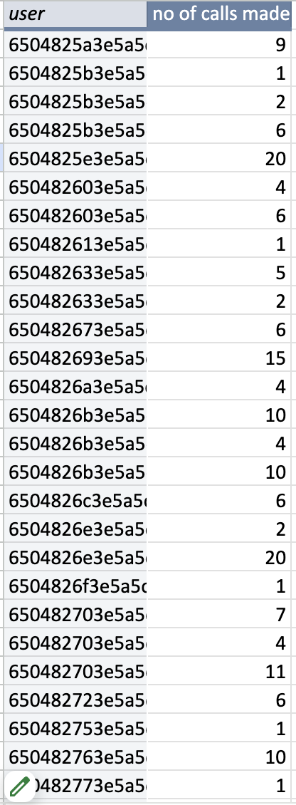

* Applied count function over the first column to count the total number of callers.

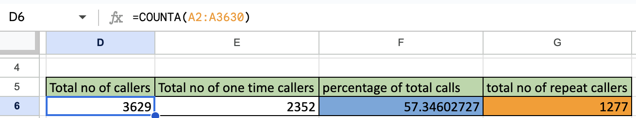

* Applied the COUNT function to count the number of users who made only a single call.

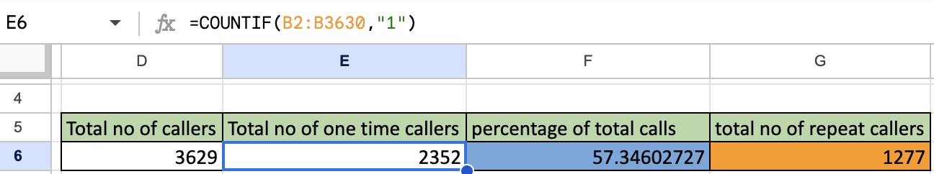

* Subtracted Total One time callers from Total number of callers to get repeat callers.

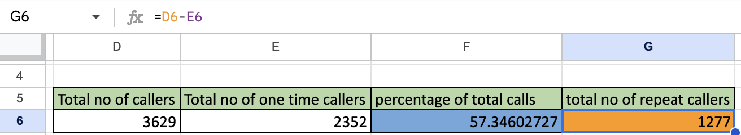

In order to obtain the percentage of total calls that repeat callers represent,

Formula used is:

(Total number of Call - Total number of Callers)x100/total number of calls

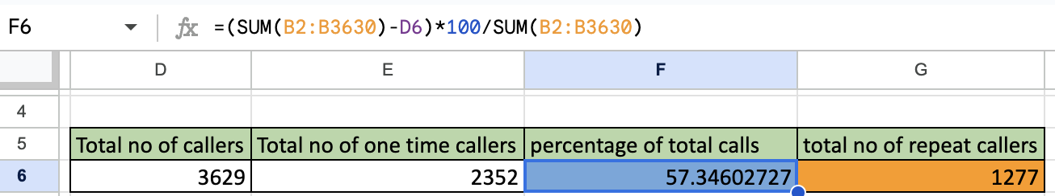

1. **What is the total sales generated by the call center for each product category?**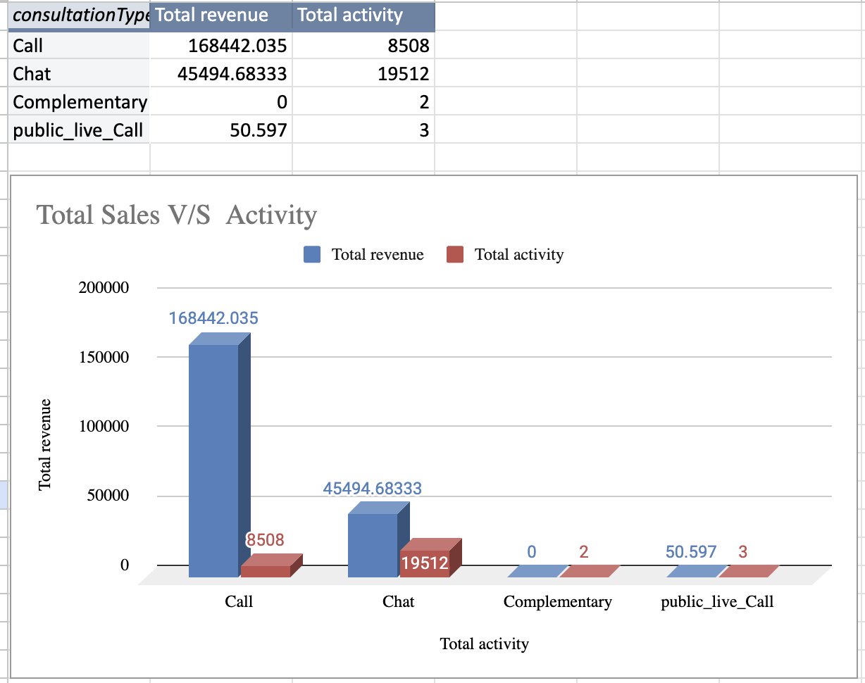

* The chart from the dashboard displays the sales generated for each product category.
* The data shown in red represents the number of activities received by different products or consultation types.
* The data shown in blue represents the revenue generated from each product or consultation type.

1. **How many calls were made for each user ID and guru ID?**

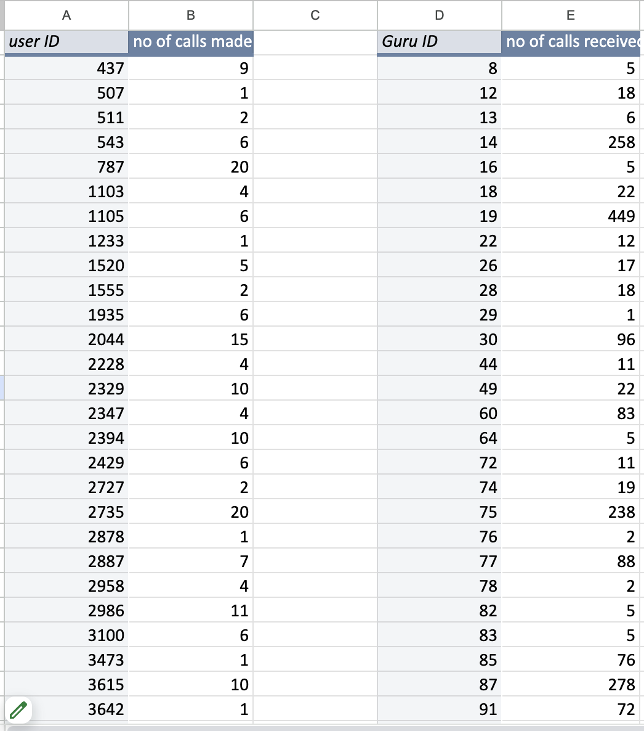

Answer: The two pivot tables provides:

* The number of calls made by each user.
* The number of calls received by each agent or guru.

1. **What is the correlation between call duration and customer satisfaction?**

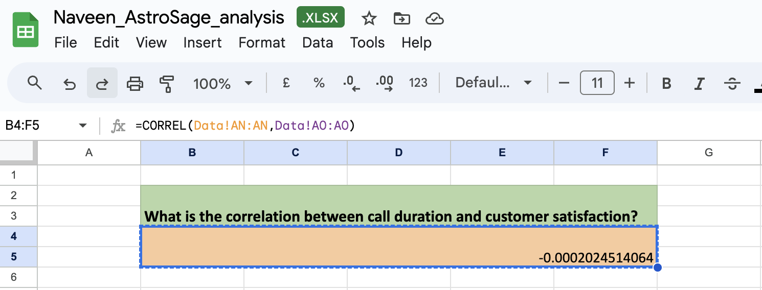

* Metric for Customer Satisfaction:
  + Since there was no specific column for customer satisfaction, the rating was used as a stand-in.
* Correlation Formula:
  + The formula used was CORREL(Range of UserOnCallDuration, Range of Ratings).
* Correlation Result
  + The correlation coefficient was -0.0002024514064
* Direction of Relationship:
  + This result shows a very weak negative correlation. As call duration increases, customer satisfaction decreases slightly, but the effect is very small.

1. **Which guru have the highest and lowest customer satisfaction scores?**

Answer:

* Guru with highest average rating - Tarot Mystical
* Guru with lowest average rating - Tarot Rittika

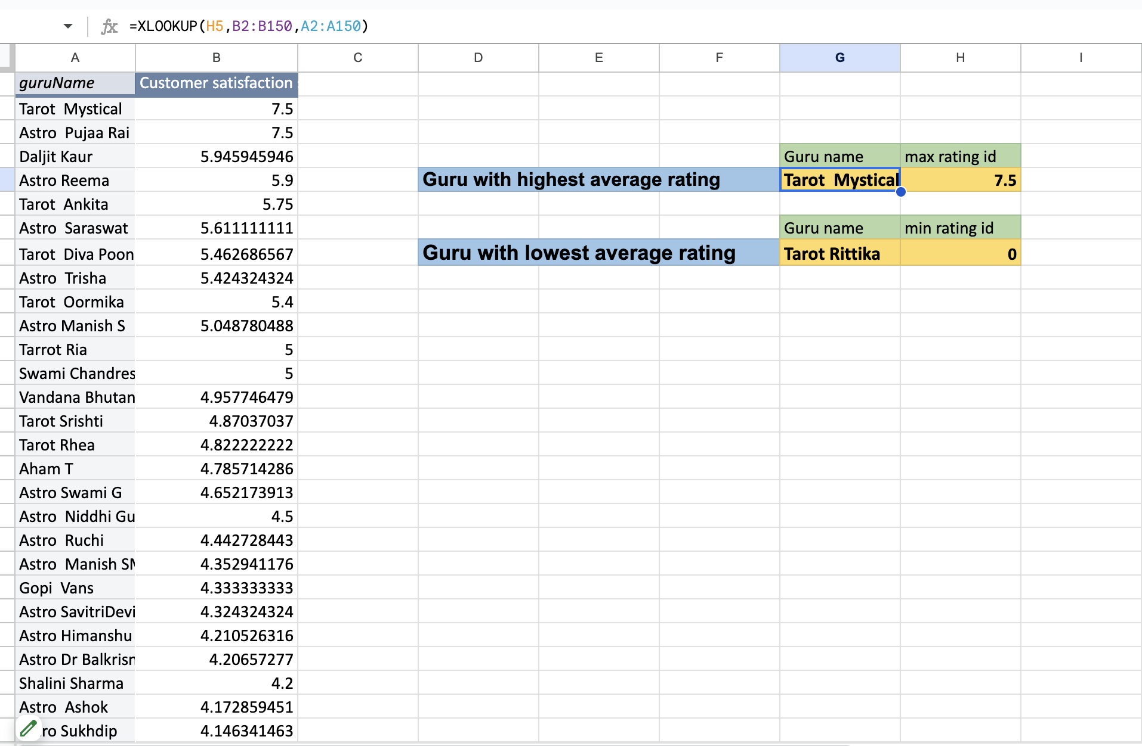

* Created a pivot table and added Guruname as rows and Average of Rating as values to assess the average rating of each guru/agent.
* Click on the dropdown arrow next to the Average of Customer Satisfaction Score.
* Choose Sort Largest to Smallest to display the guru with the highest average rating at the top.
* Used appropriate functions to find the Guruname corresponding to the maximum and minimum average ratings. The functions used were MAX, MIN, and XLOOKUP.
* Used the obtained Gname values to fetch the corresponding guru names using XLOOKUP.

1. **What is the average customer satisfaction score by month?**

Answer:

The Pivot Table will show the average customer satisfaction score for each month.

Rows:

* Drag the Month field to the Rows area. This will list each month in rows.

Values:

* Drag the Customer Satisfaction Score field to the Values area.
* Click on the Values field and set it to summarize by Average to calculate the average score for each month.

| *Month* | Average customer satisfaction score |
| --- | --- |
| December | 2.949637572 |
| January | 2.676413255 |

1. **How many categorical columns are there in the data? [Search about categorical and continuous data, and try to answer this question]**

Ans. 21

_id, user, chatStatus, guru, guruName, consultationType, website, refundStatus, isWhiteListUser, queue, freeCall, freeChat, __v, statementEntryId, callChannel, callIvrType, callStatus, astrologerCallStatus, region, userCallStatus

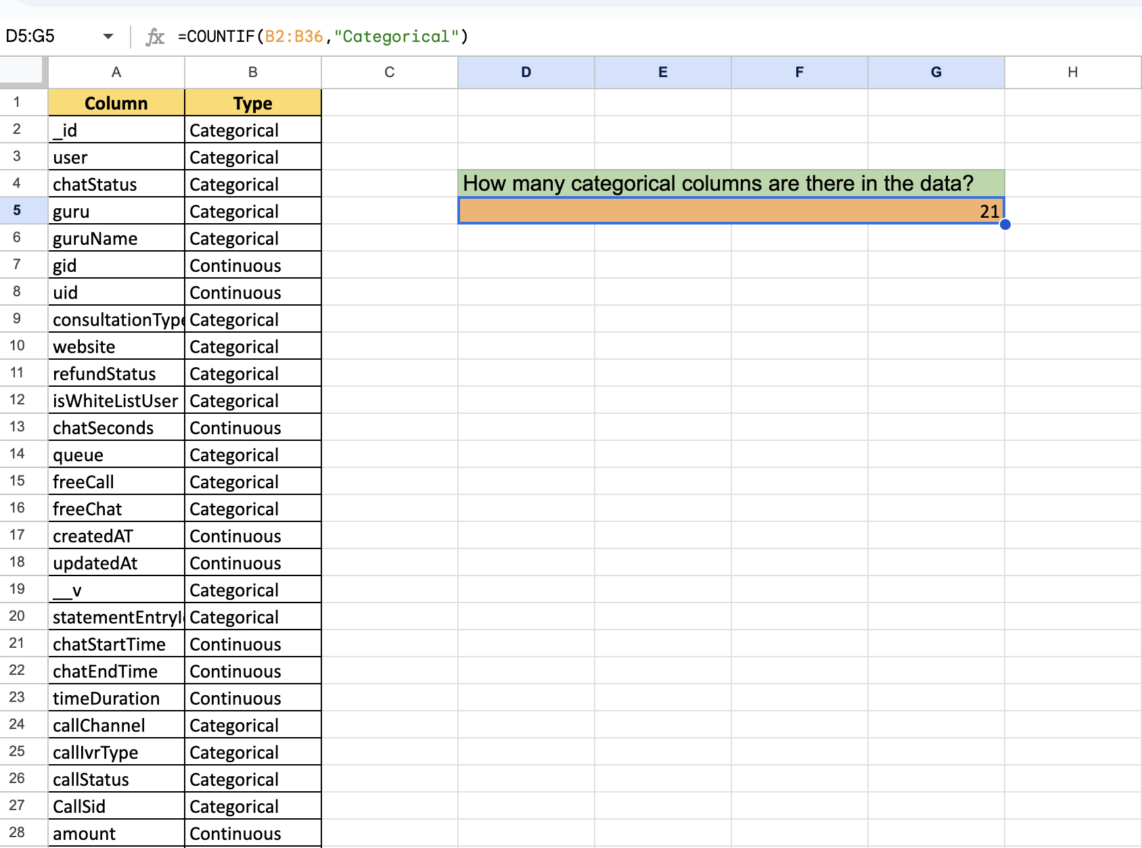

**Subjective Question:**

1. Should the investment be used to hire more agents, improve training programs, or upgrade call center technology?

Answer. After analyzing the data provided below are the findings:

Findings:

* Daily active users decreasing on both app and website:
  + Daily Active Users (DAUs): The number of daily active users fluctuates significantly across the provided dates. Notably, there are some days with high activity and others with lower activity.
  + Platform Activity: There is a clear variance in DAUs across different platforms (website, app, gurucool). Each platform exhibits unique trends.
  + Website: DAUs on the website show significant variation, with the highest activity recorded on 15/12/2023 (1094 users) and the lowest on 08/12/2023 (204 users).
  + App: DAUs on the app also exhibit fluctuation, with the highest on 14/12/2023 (722 users) and the lowest on 06/12/2023 (270 users).
  + Gurucool: DAUs on the gurucool platform display a considerable range, with peaks and troughs similar to the other platforms.

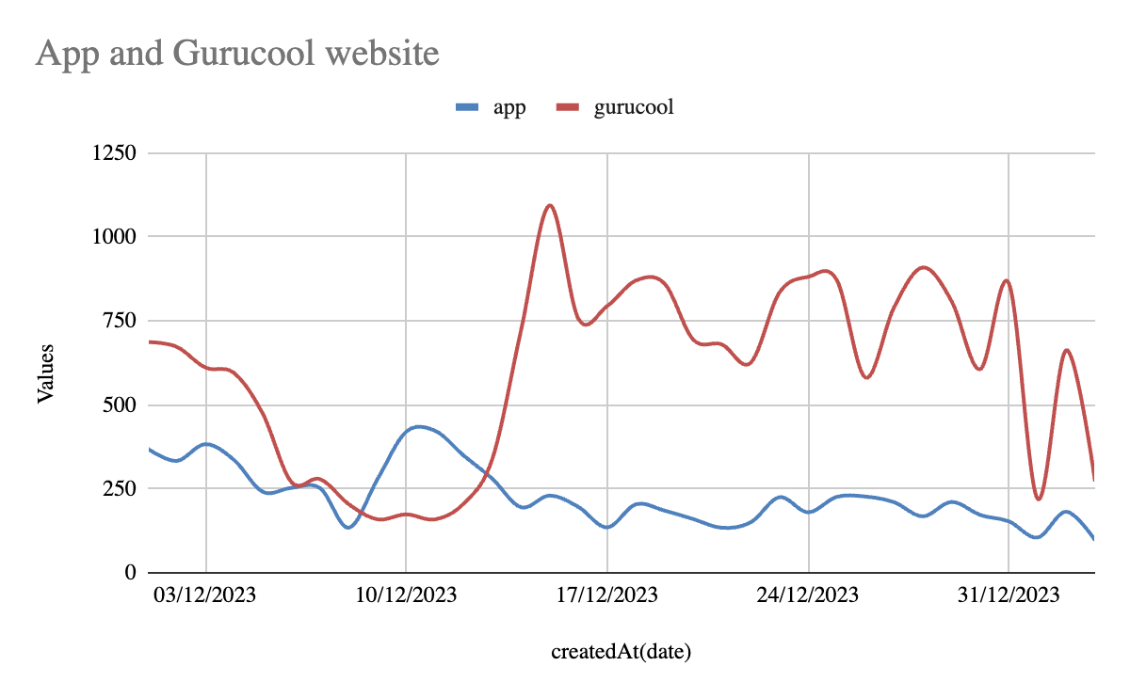

* Revenue Analysis by Call vs Chat:
  + Calls generate significantly more revenue compared to chats.
  + Completed Calls alone account for the majority of the revenue (Rs 168,492.63), while Completed Chats generate much less revenue (Rs 45,465.10).
  + Calls are a major revenue driver; increasing the number of completed calls could lead to higher revenue.
  + Chats are less profitable; improving chat monetization or conversion rates could enhance revenue.
  + Calls: Enhance processes to increase call completion rates and address issues leading to incomplete calls.
  + Chats: Investigate and address reasons for non-revenue statuses to improve conversion to completed chats.

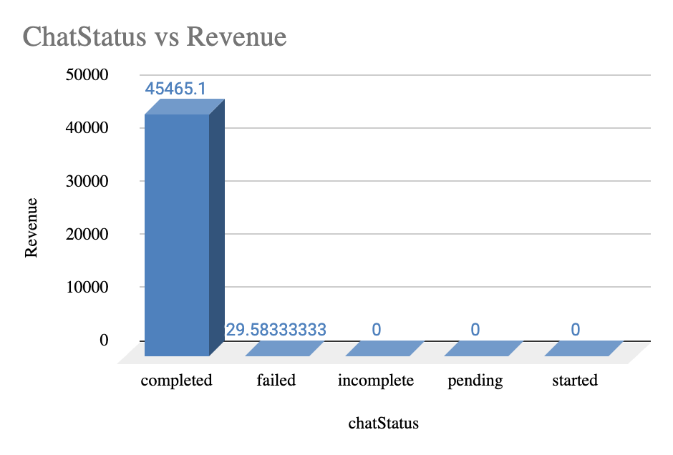

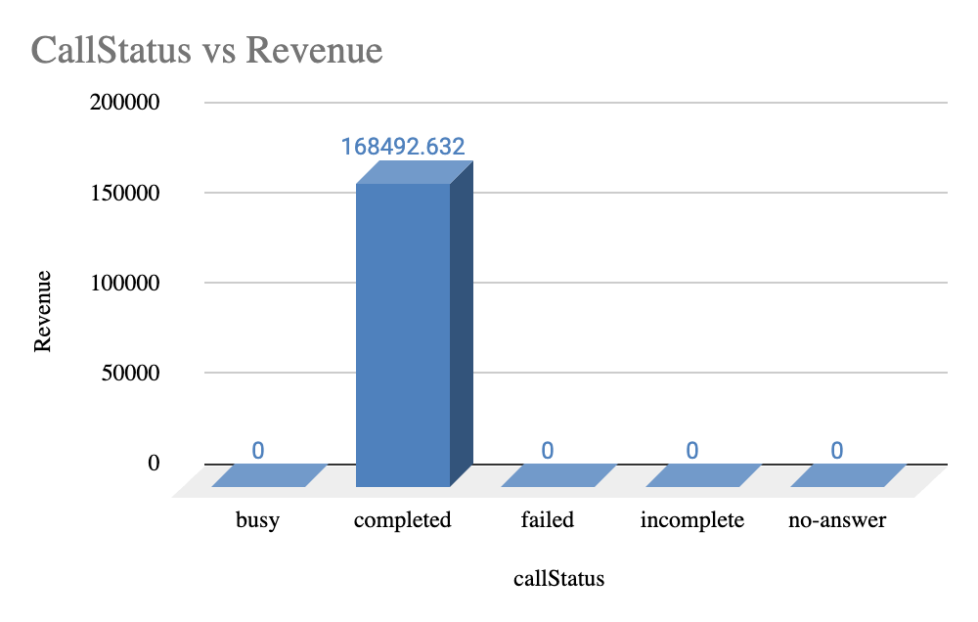

* Rating Distribution:
  + Overall Average Rating: The grand total average rating is approximately 2.93.
  + Highest Ratings: IDs with the highest ratings include 286 (5.9), 287 (5.75), and 253 (5.05).
  + Lowest Ratings:IDs with the lowest ratings include 80 (0), 219 (0.10), and 307 (0.79).
  + Improve Low Ratings: Investigate and address the causes behind the extremely low ratings to enhance user experience.
  + Leverage High Ratings: Analyze successful IDs to replicate their positive aspects in other areas.

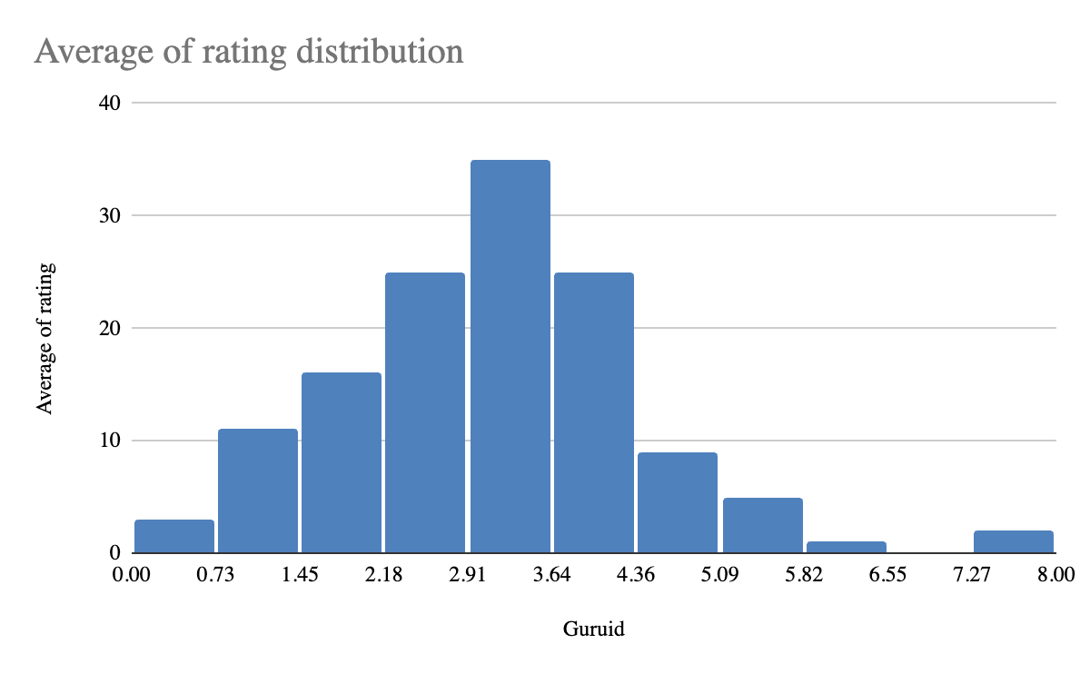

### **Investment Recommendations: Hiring, Training, or Technology**

#### **1. Focus on Completing Calls**

* **Findings**: Completed calls are the main source of revenue, generating **Rs 168,492.63**, compared to **Rs 45,465.10** from chats. Increasing successful calls is vital for revenue growth.
* **Recommendations**:
  + **Hire More Agents**: Increase staffing levels during peak times to effectively manage call volume and reduce wait times.
  + **Upgrade Call Center Technology**: Invest in systems that improve call routing and monitoring, ensuring efficient call handling.

#### **2. Improve Chat Conversions**

* **Findings**: Chats are less profitable than calls, indicating a need for better efficiency in chat handling.
* **Recommendations**:
  + **Enhance Training Programs**: Focus on effective chat management training for agents to improve conversion rates from chats to completed transactions.
  + **Technology Enhancements**: Implement AI-driven tools or chatbots to assist agents, increasing efficiency and potentially leading to more completed chats.

#### **3. Address Low Ratings**

* **Findings**: The average rating is low at **2.93**, with instances of very low ratings that can harm the brand's image.
* **Recommendations**:
  + **Improve Training Programs**: Develop training focused on customer service excellence and problem-solving to enhance agent performance and customer satisfaction.
  + **Utilize Technology**: Employ analytics to identify common issues affecting ratings and create feedback mechanisms for real-time customer input.

### 

### 

### **Conclusion**

* **Hiring**: Prioritize hiring more agents to effectively manage call volume during peak periods.
* **Training**: Focus on comprehensive training to improve agent skills for both calls and chats, enhancing customer interactions.
* **Technology**: Implement technology solutions to streamline operations and improve overall service quality.

1. **What are the potential risks of each investment option (hiring, training, technology upgrades), and how can they be mitigated?**

**Name the chart/spreadsheet function you will use for solving the problem?**

Answer:

Technology Upgrades:

1. Risks:

* Implementation Challenges: Time-consuming and potential technical issues.
* High Upfront Costs: Significant initial investment with delayed returns.

2. Mitigation Strategies:

* Phased Rollout: Test in smaller phases to address issues gradually.
* Cost-Benefit Analysis: Ensure investment aligns with efficiency and profitability gains.

3. Spreadsheet Functions:

* WHATIF Analysis: Assess impact of changes in costs and rollout timelines.
* Goal Seek: Find breakeven point for investment.
* Charts:
  + Bar Charts: Compare costs and benefits.
  + Waterfall Charts: Show incremental impacts.

Agent Training:

1. Risks:

* High Costs: Expensive and may reduce productivity during training.
* Retention Issues: Risk of trained agents leaving.

2. Mitigation Strategies:

* Measure Effectiveness: Track and refine training based on performance metrics.
* Retention Programs: Offer incentives to retain trained agents.

3. Spreadsheet Functions:

* WHATIF Analysis: Evaluate effects of training costs and number of agents.
* Goal Seek: Determine optimal training investment level.
* Charts:
  + Bar Charts: Show costs and benefits of training programs.
  + Pie Charts: Display cost distribution.

1. **How does AstroSage call center performance compare to that of AstroGuru in terms of average call volume, customer satisfaction, and agent performance?**

**Will you use any aggregation function or a visualization here to solve the problem?**

**Answer: AstroGuru’s data is not provided, so I am using only AstroSage's data to calculate the average call volume, customer satisfaction, and agent performance.**

* Average Call Volume:
  + Definition: This refers to the average number of calls handled by each call center over a specific period.
  + Highest Call Volume: The agent with the highest call volume is Krishaa with 1580 calls.
  + Lowest Call Volume: The agent with the lowest call volume is Rittika with just 1 call.
  + General Observation: Call volumes vary widely among agents, with some having extremely high call volumes (e.g., Sakthi with 1450 calls) and others with very low numbers.
* Customer Satisfaction:
  + Definition: This is usually measured through surveys or feedback scores provided by customers after their interactions with the call centers.
  + Highest Rating:Pujaa Rai: 7.50,Mystical: 7.50
  + Lowest Rating: Rittika: 0.00
  + General Observation: Customer satisfaction ratings vary widely, with some individuals achieving very high ratings and others very low. High ratings tend to be in the 4.00-7.50 range, while low ratings often fall below 1.00.

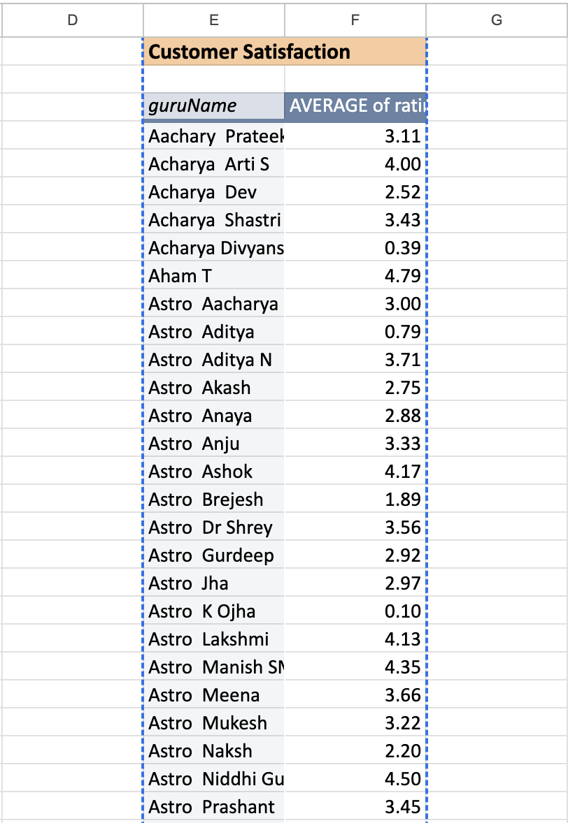

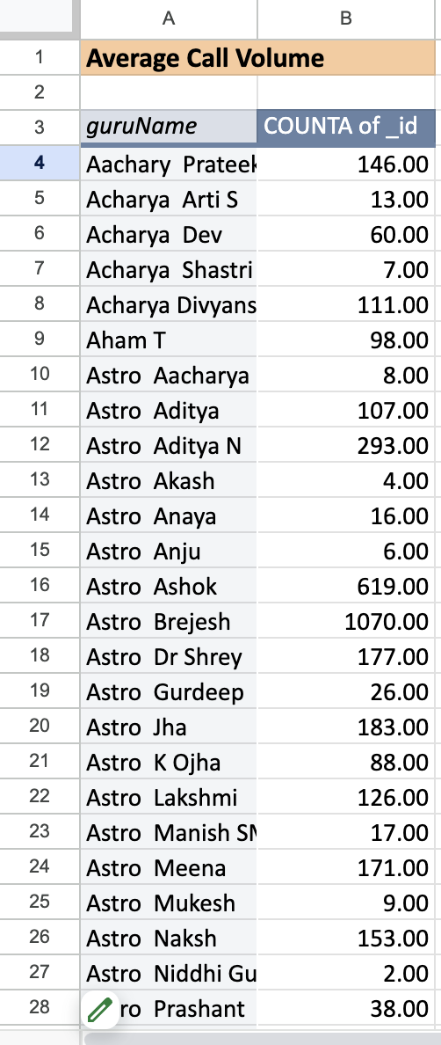

* Agent Performance:
  + Definition: This can be assessed through various metrics such as average handling time, resolution rate, or the number of successful calls.
  + High Performers:
  + Krishaa: High call volume and relatively high customer satisfaction rating (3.33).
  + Seema: High call volume (605 calls) with a decent customer satisfaction rating (3.40).
  + Low Performers:
  + Rittika: Extremely low call volume (1 call) and the lowest satisfaction rating (0.00).
  + K Ojha: Very low satisfaction rating (0.10) with a moderate call volume (88 calls).

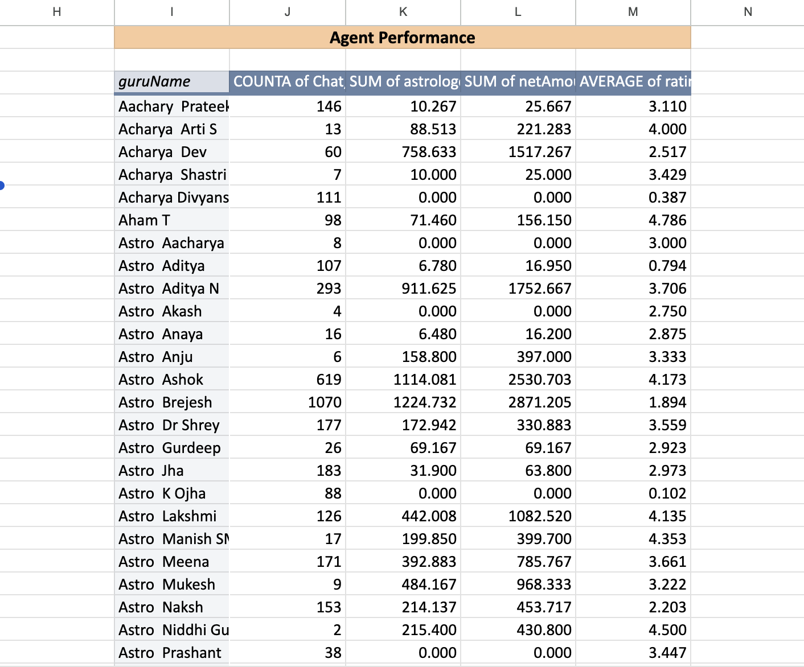

1. **How can the call center improve its handling of peak call periods to ensure high customer satisfaction?**

Mention the functionality which you will use for giving the suggestions, will it be any aggregate function or a visualization?

Answer.

* Creating a pivot table to summarize the data of hourly volume v/s day.
* Extracting the hours from the date of creation by utilizing Right and Left functions.

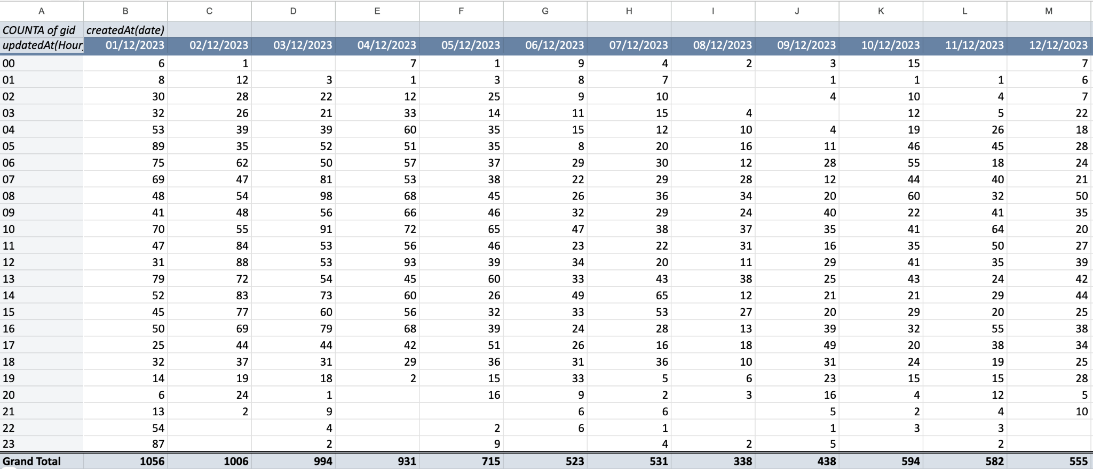

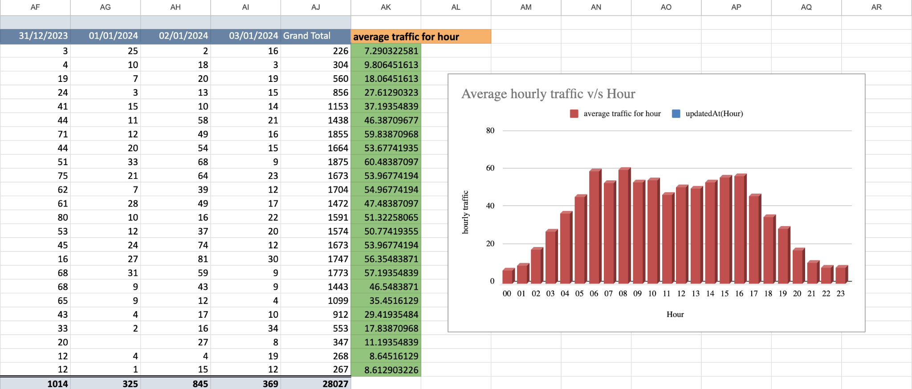

The given chart depicts the data of Average hourly traffic on the Y-axis and the hour of the day on the X-Axis.

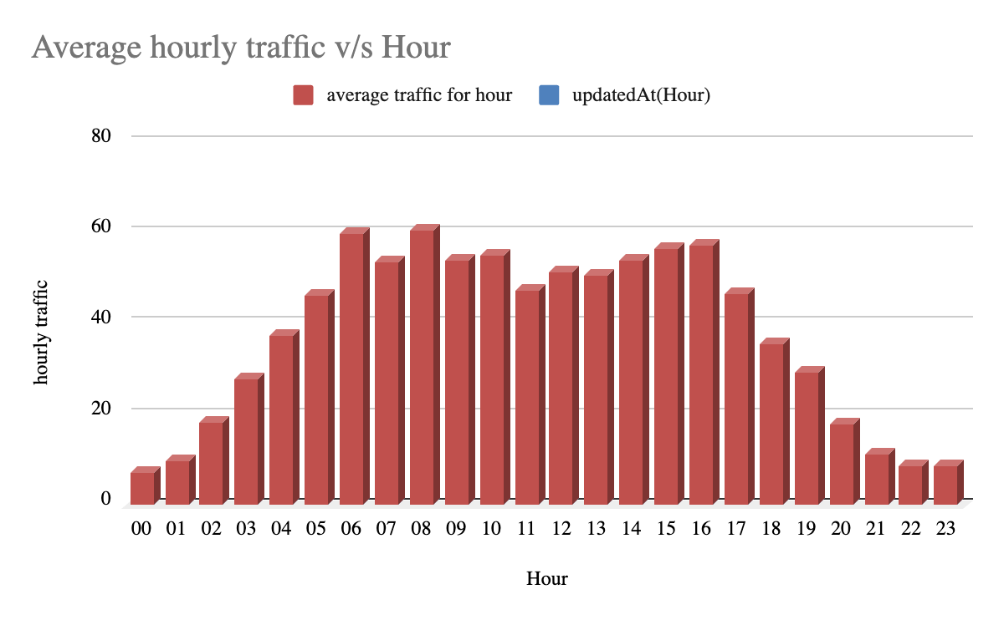

Inference from the data:

* Peak Traffic Hours:
  + Hour 08:00: Highest average call volume of 60.48 calls/hour.
* Lowest Traffic Hours:
  + Hour 21:00: Lowest average call volume of 11.19 calls/hour.
* Overall Average Traffic:
  + The overall average traffic per hour is approximately 35.45 calls/hour.
* Grand Total: 28,027 calls over the period.

Suggestions:

* Increase Staffing During Peak Hours:
  + Hours to Focus On: 08:00 and 09:00, which show the highest call volumes.
  + Action: Consider adding more staff or extending working hours during these periods to handle the increased call volume.
* Adjust Staffing for Low Traffic Hours:
  + Hours to Reduce Staffing: 21:00 and 22:00, which have the lowest call volumes.
  + Action: Reduce the number of staff during these hours to optimize labor costs and resource utilization.

1. **Based on historical data, what strategic initiatives should be prioritized to improve overall efficiency and customer satisfaction?**

Answer:

Based on historical call center data and the goal of improving overall efficiency and customer satisfaction, the following strategic initiatives should be prioritized:

1. Selected Training for Poor Performing Agents

Analyzing the historical data, it will be seen that there are some agents whose failure rates are very high, and the customers’ ratings are also poor. There is much that targeted training can do to enhance their performance, decrease call failure rate, and increase customers’ satisfaction.

Action :

Find the agents with low ratings and agents with many failures.

Create effective training sessions based on the employees’ need for improvement in such areas as communication skills, problem-solving skills, and technical knowledge.

It is necessary to assess changes in performance after training so that it is possible to determine whether the training was beneficial.

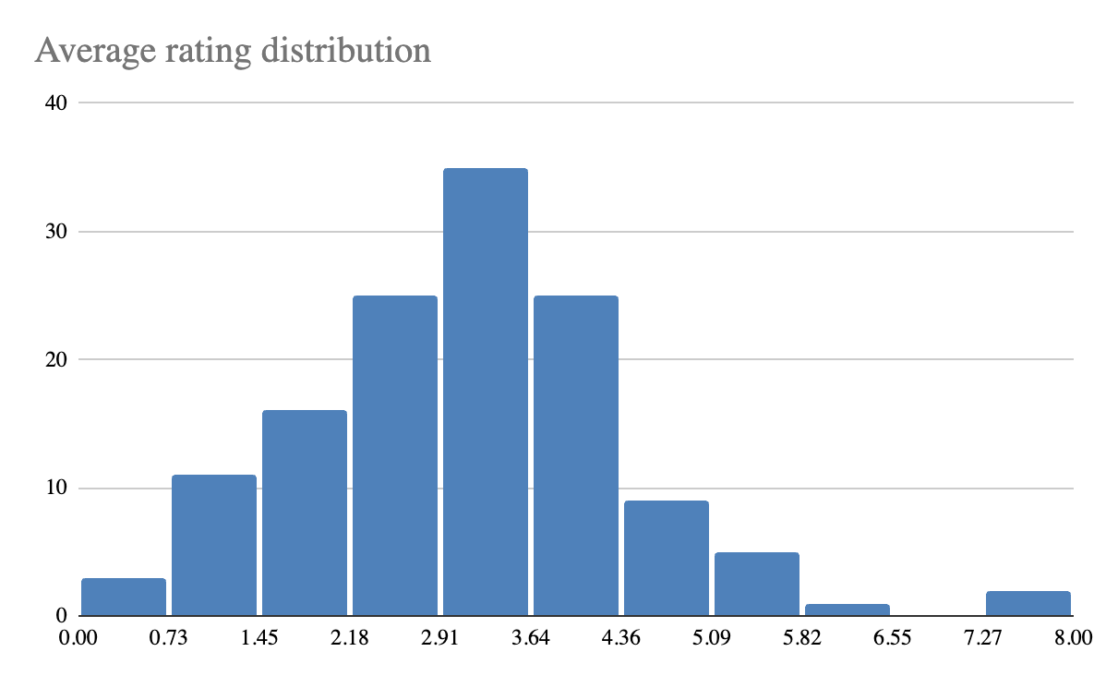

Given picture shows the distribution of Rating across the Agents.

It can be seen that the majority of the data lies in the left half showcasing the lower satisfaction of the customers.

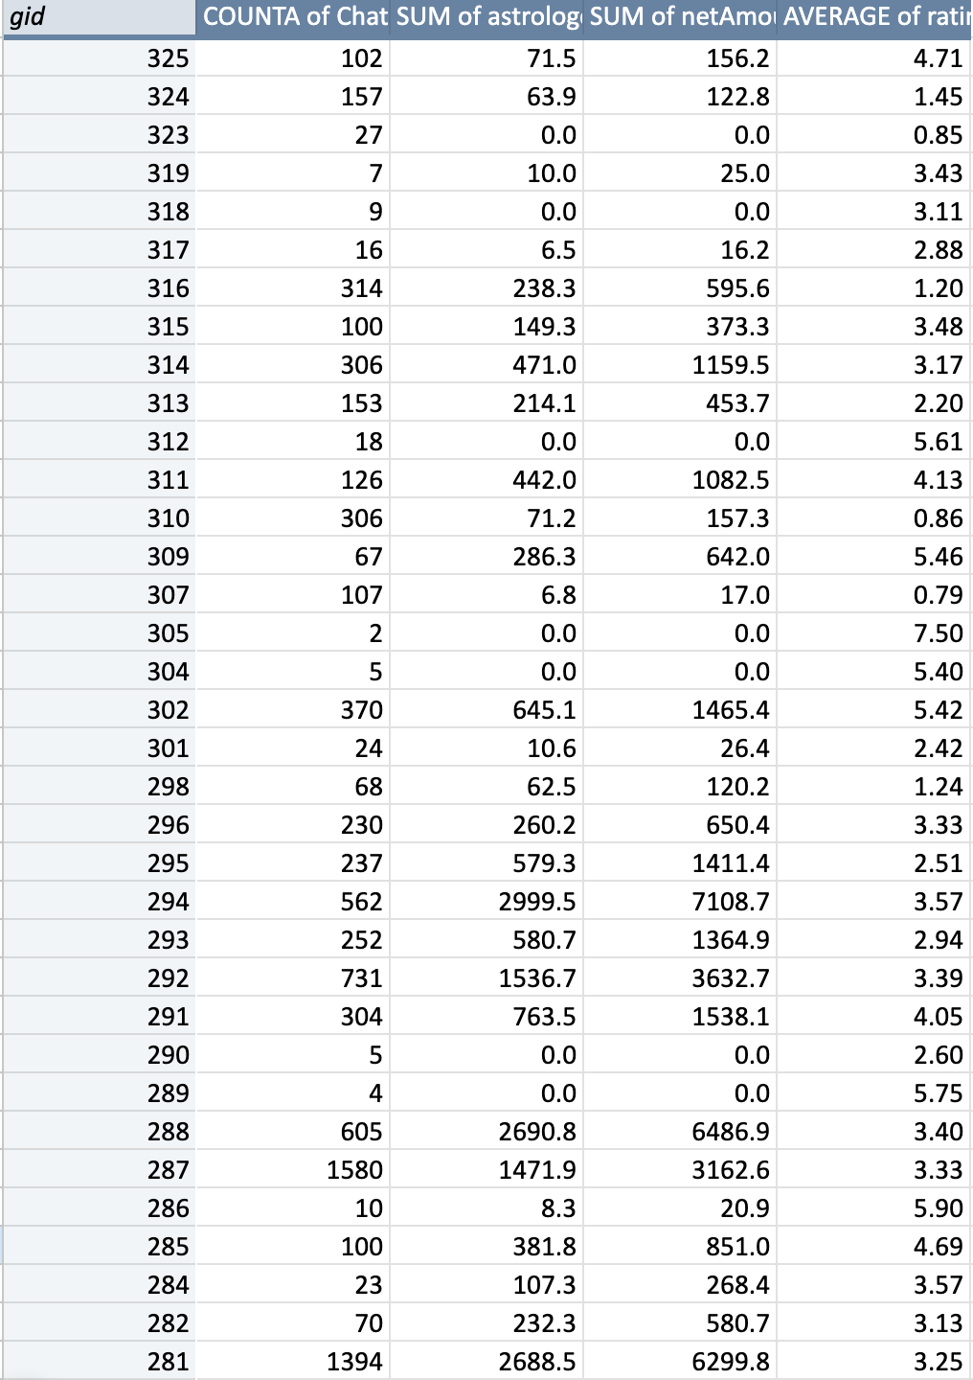

The rating distribution can be analysed through the above pivot table and appropriate actions like targeted training can be taken for special cases.

2. Improved Call Management and Call Priority

Poor call routing directs customers to stay longer on the line, become unhappy, and agents may be used inappropriately. There is a possibility of intelligent call routing systems to match the needs of the customers with the right agents.

Action:

Utilize skill-based routing that will help to route the calls to agents who will be in the right position to attend to the call.

Implement the concept of priority queuing so that valued or returning customers receive their services earlier, especially during the rush hour.

Deduce and periodically update routing rules with the help of performance reports.

3. Measures to Minimize Call Failure Risks Due to Technological Enhancements

Rationale: This is because records of past calls may show call failures or technical challenges that are displeasing to the customers. It is therefore possible to recommend that organizations seek to upgrade the technology used in call centers since this would increase call quality, reduce failure incidences, and increase efficiency.

Action Items:

The communication should also be more reliable and have a larger capacity, and this is why one should think about investing in a better infrastructure.

Introduce or enhance effective IVR systems to minimize the need for agents in handling simple calls.

Avail the services of monitoring and diagnosis tools in order to diagnose technical problems as they surface.

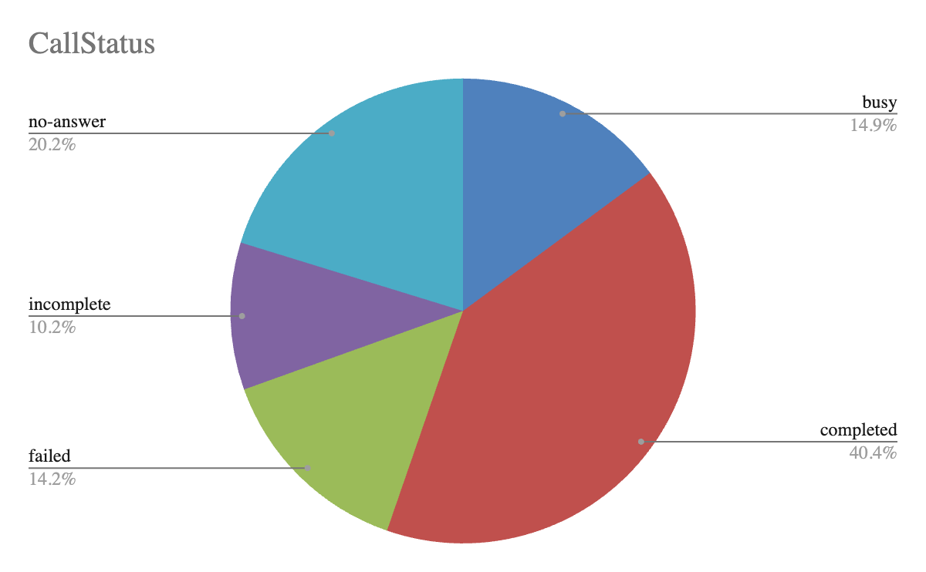

The Given Chart shows the failure rate of calls.

4. Improved Self-Service Options

This is because customers are now able to use self-service to solve most of the questions that they have frequently. This can effectively help in cutting down on the number of calls made during peak hours self-service through IVR, chatbot or through online portals.

Action :

Integrate IVR systems to be further developed to address numerous questions which do not require the assistance of the agents.

I recommend the use of AI based chatbots to help customers solve simple problems that they come across.

The more the customers are encouraged to use self-service, the more effective they are when it comes to conveying information and providing interfaces.

Conclusion: Prioritizing targeted training, technology upgrades, enhanced call routing, workforce optimization based on historical data will lead to significant improvements in overall efficiency and customer satisfaction.

1. **What can be the key factors contributing to high customer satisfaction scores, and how can these be leveraged to improve overall performance?**

**What is the basis for the suggestions? And mention how did you decide if the satisfaction score affect the ratings?**

Answer:

| *gid* | COUNT of uid | AVERAGE of rating |
| --- | --- | --- |
| 287 | 1580 | 3.33 |
| 239 | 1450 | 2.54 |
| 281 | 1394 | 3.25 |
| 256 | 1321 | 3.42 |
| 235 | 1070 | 1.89 |
| 257 | 1056 | 3.48 |
| 19 | 967 | 2.98 |
| 75 | 777 | 4.44 |
| 271 | 752 | 3.72 |
| 87 | 743 | 2.36 |
| 201 | 735 | 1.01 |
| 292 | 731 | 3.39 |
| 241 | 704 | 1.80 |
| 261 | 678 | 2.83 |
| 274 | 619 | 4.17 |
| 288 | 605 | 3.40 |
| 255 | 588 | 2.84 |
| 294 | 562 | 3.57 |
| 247 | 540 | 1.85 |

↨ ↨ … ↨ ↨

| 97 | 2 | 7.50 |
| --- | --- | --- |
| 78 | 2 | 2.50 |
| 76 | 2 | 4.50 |
| 29 | 2 | 1.50 |
| 80 | 1 | 0.00 |
| **Grand Total** | **28025** | **2.93** |

| *callStatus* | COUNTA of CallSid |
| --- | --- |
| busy | 15.18% |
| completed | 41.26% |
| failed | 12.43% |
| incomplete | 10.46% |
| no-answer | 20.67% |
| **Grand Total** | **100.00%** |

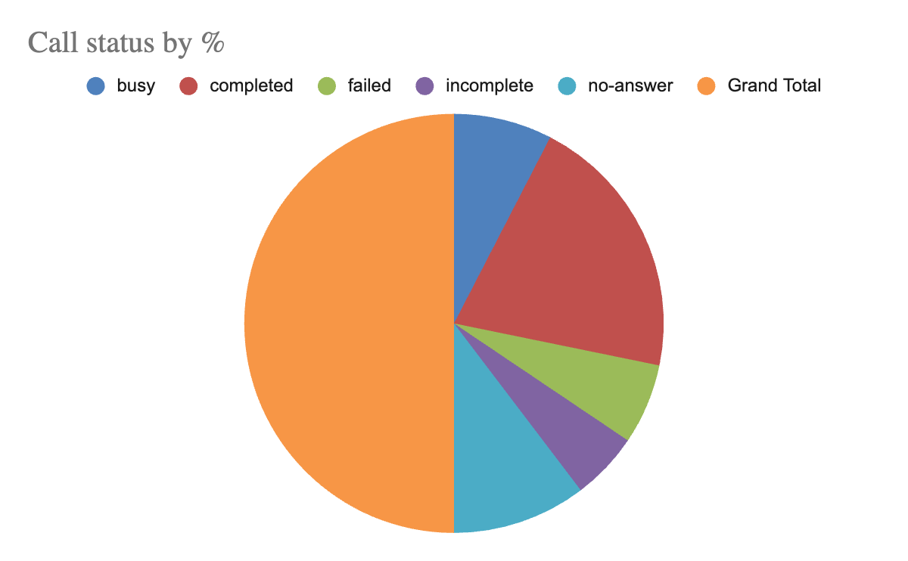

### **Key Factors Influencing Customer Satisfaction**

1. **Agent Expertise**:
   * Agents with specialized knowledge tend to receive higher ratings. Notable examples include agents with high average ratings who handle complex queries effectively.
2. **Manageable Call Volumes**:
   * Lower customer loads per agent generally correlate with better ratings. Overburdened agents often struggle to maintain service quality.
3. **Targeted Customer Assignments**:
   * Matching customers with agents who have relevant expertise can enhance satisfaction. Prioritizing complex cases for experienced agents can lead to improved outcomes.
4. **Ongoing Training**:
   * Regular training programs help agents improve both their technical skills and customer service abilities, which can elevate overall satisfaction.
5. **Feedback Utilization**:
   * Implementing effective feedback systems allows agents to learn and adapt based on customer insights, directly impacting their ratings.
6. **Recognition of Performance**:
   * Acknowledging high-performing agents can motivate all staff to enhance their service levels, fostering a culture of excellence.

### **Suggestions for Improvement**

* **Rebalance Customer Distribution**: Ensure that agents with high ratings manage a reasonable number of cases to sustain service quality.
* **Enhance Training Opportunities**: Focus training efforts on agents with lower performance ratings to help them improve.
* **Mentorship Initiatives**: Pair less experienced agents with high performers to facilitate skill development.
* **Analyze Customer Feedback Regularly**: Use feedback to identify specific improvement areas for each agent.
* **Monitor Workloads Closely**: Adjust staffing to prevent agent overload, ensuring consistent quality in customer interactions.
* **Assign Customers Based on Complexity**: Match customer needs with agent expertise to provide tailored support.

### **Decision-Making Regarding Satisfaction Scores**

To determine the impact of satisfaction scores on ratings, the following approaches were used:

* **Statistical Correlation**: Analyzed the relationship between agent ratings and their handling of various call types. Higher ratings were consistently associated with lower call failure and busy statuses.
* **Performance Review**: Evaluated feedback from customers and the performance metrics of agents, noting trends in how expertise and manageable workloads affected customer experiences.
* **Historical Patterns**: Reviewed past data trends indicating that agents with higher satisfaction scores maintained better service quality, thereby improving overall performance ratings.

1. **How should the call center balance the workload among agents to ensure optimal performance and avoid burnout?**

**Mention your approach and spreadsheet function for the answer?**

Answer:

| *gid* | Chats/Calls Handled | Earnings | Net Amount | Average of rating | Status |
| --- | --- | --- | --- | --- | --- |
| 325 | 102 | 71.46 | 156.15 | 4.71 | Balanced |
| 324 | 157 | 63.88 | 122.83 | 1.45 | Balanced |
| 323 | 27 | 0.00 | 0.00 | 0.85 | Balanced |
| 319 | 7 | 10.00 | 25.00 | 3.43 | Balanced |
| 318 | 9 | 0.00 | 0.00 | 3.11 | Balanced |
| 317 | 16 | 6.48 | 16.20 | 2.88 | Balanced |
| 316 | 314 | 238.26 | 595.65 | 1.20 | Overloaded |
| 315 | 100 | 149.32 | 373.29 | 3.48 | Balanced |
| 314 | 306 | 470.95 | 1159.51 | 3.17 | Overloaded |
| 313 | 153 | 214.14 | 453.72 | 2.20 | Balanced |
| 312 | 18 | 0.00 | 0.00 | 5.61 | Balanced |
| 311 | 126 | 442.01 | 1082.52 | 4.13 | Balanced |
| 310 | 306 | 71.17 | 157.30 | 0.86 | Overloaded |
| 309 | 67 | 286.29 | 641.97 | 5.46 | Balanced |
| 307 | 107 | 6.78 | 16.95 | 0.79 | Balanced |
| 305 | 2 | 0.00 | 0.00 | 7.50 | Balanced |
| 304 | 5 | 0.00 | 0.00 | 5.40 | Balanced |
| 302 | 370 | 645.07 | 1465.43 | 5.42 | Overloaded |
| 301 | 24 | 10.56 | 26.40 | 2.42 | Balanced |
| 298 | 68 | 62.53 | 120.20 | 1.24 | Balanced |
| 296 | 230 | 260.16 | 650.40 | 3.33 | Overloaded |
| 295 | 237 | 579.31 | 1411.41 | 2.51 | Overloaded |
| 294 | 562 | 2999.49 | 7108.73 | 3.57 | Overloaded |
| 293 | 252 | 580.67 | 1364.93 | 2.94 | Overloaded |
| 292 | 731 | 1536.67 | 3632.67 | 3.39 | Overloaded |
| 291 | 304 | 763.48 | 1538.07 | 4.05 | Overloaded |
| 290 | 5 | 0.00 | 0.00 | 2.60 | Balanced |
| 289 | 4 | 0.00 | 0.00 | 5.75 | Balanced |
| 288 | 605 | 2690.82 | 6486.92 | 3.40 | Overloaded |

| Total Number of Interactions | | |
| --- | --- | --- |
| 28027 | | |
|  |  |  |
|  |  |  |
| The Average Workload | | |
| 213.9465649 | | |
|  |  |  |
|  |  |  |
| Average Earnings | | |
| 756.84 | | |
|  |  |  |
|  |  |  |
| Average Ratings | | |
| 3.15 | | |

* **Assess Workload Distribution**
  + Begin by calculating the total number of chats and calls handled by each agent. This will help you understand how the workload is currently distributed.
  + To find the total number of interactions:
  + =SUM(B2:B100) // Where column B contains (Chats/Calls Handled)
* **Compute Average Workload per Agent**
  + Next, determine the average workload for agents by dividing the total number of interactions by the number of agents.
  + To find the average:
  + =AVERAGE(B2:B100) // Where column B contains (Chats/Calls Handled)
* **Identify Overburdened Agents**
  + Identify agents whose workloads are above the average. You can use conditional formatting to highlight these agents for better visibility.
  + To check if an agent is overloaded:
  + =IF(B2 > AVERAGE($B$2:$B$100), "Overloaded", "Balanced")
* **Reallocate Workload**
  + For agents who are overloaded, consider redistributing tasks to those who have a lighter workload. This may involve:
  + Shifting calls or chats from agents with high volumes to those with lower ones.
  + Rotating responsibilities regularly to maintain a balanced workload.
* **Monitor Performance Metrics**
  + Continuously track performance indicators like earnings and ratings to see if the adjustments in workload lead to improved outcomes.
  + To calculate average earnings and ratings:
  + =AVERAGE(C2:C100) // For earnings
  + =AVERAGE(E2:E100) // For ratings

**Justification for Enhancing Performance and Preventing Burnout**

Balancing workloads is essential to sustain agent morale and productivity. Agents who are overwhelmed with too many calls may face burnout, resulting in lower performance, increased turnover, and adverse effects on customer service. The provided data allows for a thorough analysis of individual workloads. By redistributing tasks, the call center can create a more manageable and sustainable work environment.

Regular monitoring of workload alongside performance metrics will ensure that no agent is consistently overworked, thus promoting both operational efficiency and employee well-being.

**Conclusion**

Through data analysis and effective use of spreadsheet functions, the call center can optimize agent workloads, leading to fairer task distribution and improved employee satisfaction as well as service quality.

1. **What new technologies or tools could be implemented to enhance call center operations and customer service?**

**Answer: To enhance call center operations and customer service, several new technologies and tools can be implemented:**

1.AI-Powered Chatbots and Virtual Assistants

* Description: AI chatbots can handle routine inquiries, provide 24/7 support, and free up human agents for more complex issues. Virtual assistants can assist with tasks like appointment scheduling and providing information.
* Benefits: Reduced wait times, lower operational costs, and improved response accuracy.

2. Speech and Text Analytics

* Description: Technologies that analyze spoken and written communications to understand customer sentiment, detect issues, and identify opportunities for improvement.
* Benefits: Improved customer insights, enhanced quality assurance, and targeted training for agents.

3. Automated Call Distribution (ACD) Systems

* Description: Systems that use algorithms to route calls to the most appropriate agent based on their skills, availability, and previous interactions.
* Benefits: Reduced call handling times, increased first-call resolution rates, and better utilization of agent skills.

4. Customer Relationship Management (CRM) Integration

* Description: Integrating CRM systems with call center software to provide agents with comprehensive customer profiles and interaction histories.
* Benefits: Enhanced personalization, more efficient call handling, and improved customer satisfaction.

5. Workforce Management (WFM) Solutions

* Description: Tools for forecasting, scheduling, and managing the performance of call center agents.
* Benefits: Optimized staffing levels, reduced operational costs, and improved agent performance and satisfaction.

6. Voice Biometrics

* Description: Technology that uses voiceprints to authenticate and identify customers.
* Benefits: Enhanced security, faster verification processes, and reduced fraud.

7. Interactive Voice Response (IVR) Systems with AI

* Description: Advanced IVR systems that use AI to understand and respond to customer queries more naturally.
* Benefits: Improved self-service capabilities, reduced call volumes for agents, and enhanced customer satisfaction.

1. **What metrics should be included in the final dashboard to provide a comprehensive view of call center performance and guide investment decisions?**

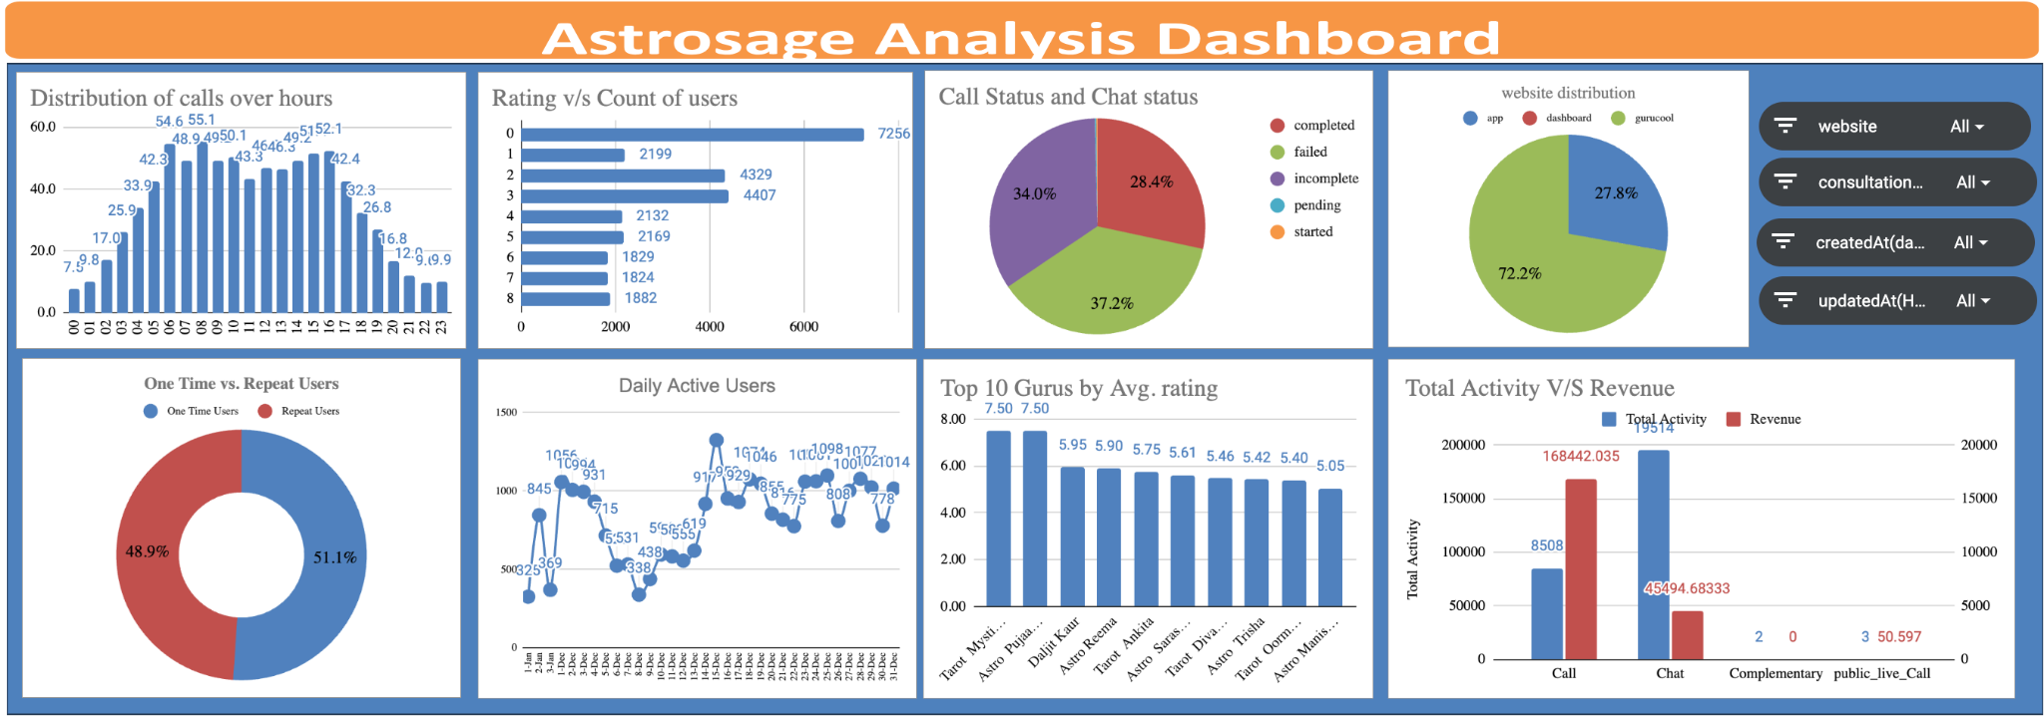

Filters

* Consultation Type Filter: Allows filtering based on different consultation types such as call, chat, complementary and public_live_call.
* Average Call Duration by Month: Track how average call duration varies each month to identify trends in service efficiency.

1. Call Volume Metrics

* Total Calls (Inbound/Outbound): Track the total number of calls to gauge demand and inform staffing needs.
* Peak Call Times: Analyze call patterns by hour and day to optimize staffing during high-demand periods.
* Call Abandonment Rate: Monitor the percentage of calls abandoned before being answered, indicating the need for more agents or improved queue management.

2. Call Duration Metrics

* Average Call Duration: Assess the average length of calls to identify training needs or inefficiencies.
* Duration Trends: Track changes in call duration over time to understand shifts in call complexity.

3. User Engagement Metrics

* Daily Active Users: Evaluate customer engagement levels to justify potential capacity expansions.
* One-Time vs. Repeat Users: Analyze retention rates to assess service quality and identify areas for loyalty improvements.

4. Service Channel Metrics

* Interaction Types: Distinguish between calls and chats to allocate resources effectively based on customer preferences.
* Consultation Type Analysis: Breakdown consultations to identify which services are most in demand.

5. Agent Performance Metrics

* Top Performers: Track agent performance by consultation count and ratings to recognize strengths and areas for development.
* Utilization Rate: Measure productive work versus downtime to optimize scheduling.
* First Call Resolution Rate: Monitor the percentage of issues resolved on the first contact, which impacts efficiency and customer satisfaction.

6. Revenue Metrics

* Total Revenue: Analyze overall revenue to understand the financial impact of operations.
* Revenue per Call/User: Evaluate profitability per interaction to inform pricing and service efficiency strategies.

7. Customer Satisfaction Metrics

* User Ratings Distribution: Review customer satisfaction ratings to identify service quality areas needing improvement.
* Customer Satisfaction Scores (CSAT): Consider adding CSAT scores for direct insights into customer perceptions.

8. Operational Efficiency Metrics

* Service Level Measurement: Track the percentage of calls answered within target times to ensure performance standards are met.
* Cost per Call Analysis: Understand the cost of handling calls to identify potential efficiency improvements.

9. Forecasting Metrics

* Call Volume Forecasting: Use historical data to predict future call volumes for effective staffing.
* Customer Base Growth: Monitor trends in user growth to anticipate resource needs.

10. Comparative Analysis

* Benchmarking: Compare metrics against industry standards to identify gaps and opportunities for improvement.
* Revenue and Consultation Trends: Visualize trends over time to guide strategic investments.

**Conclusion:**

Enhancing the dashboard with these metrics will provide a holistic view of call center performance, informing strategic investments in technology, staffing, and training. Each metric contributes to understanding different aspects of performance, allowing for well-rounded decision-making.

1. **How would you allocate a 1 crore rupee investment to optimize operational efficiency, enhance customer satisfaction, and boost profitability, and what analysis-based recommendations would you offer to support this?**

[you have to give bullet pointers in order to answer this question]

Ans:

To enhance the call center operations for AstroSage with a 1 crore investment, we will adopt a systematic approach to allocation and analysis. Below are key steps along with recommendations aimed at maximizing operational efficiency, customer satisfaction, and profitability.

Investment Allocation

1. Operational Efficiency (40% - ₹40 lakh)
   * Technology Enhancements (₹20 lakh)
     + Upgrade to advanced call routing software to minimize wait times and improve agent efficiency.
     + Deploy AI-driven predictive dialers to boost the effectiveness of outbound calls.
   * Training and Skill Development (₹10 lakh)
     + Organize regular training on customer service techniques and product information.
     + Implement coaching programs to enhance agent performance.
   * Automation of Processes (₹10 lakh)
     + Introduce automation tools for ticketing and query resolution to streamline operations.
     + Create a self-service portal for customers to handle common inquiries.
2. Customer Satisfaction (30% - ₹30 lakh)
   * Feedback Collection and Quality Assurance (₹10 lakh)
     + Establish a comprehensive system for collecting customer feedback after interactions.
     + Initiate a quality assurance program to routinely evaluate call performance.
   * Improved Communication Channels (₹10 lakh)
     + Invest in solutions that support multiple communication channels (chat, email, social media) for a cohesive service experience.
     + Implement a CRM system to monitor customer interactions and preferences effectively.
   * Tailored Customer Engagement (₹10 lakh)
     + Launch loyalty programs and personalized communication strategies to enhance customer retention.
     + Leverage analytics to customize offers based on customer behavior and history.
3. Profitability Improvement (30% - ₹30 lakh)
   * Market Research and Expansion (₹10 lakh)
     + Conduct studies to identify new customer segments and potential services.
     + Allocate budget for targeted marketing initiatives to reach these audiences.
   * Cost Optimization Strategies (₹10 lakh)
     + Review operational costs in the call center to pinpoint areas for savings (e.g., staffing and overtime).
     + Negotiate better rates with service providers and tech vendors.
   * Performance-Based Incentives (₹10 lakh)
     + Create incentive programs tied to agent performance metrics to encourage productivity.
     + Establish team rewards for achieving goals related to customer satisfaction and operational efficiency.

Recommendations Based on Analysis

1. Review Historical Call Data
   * Examine past call volume trends to determine peak periods for optimal staffing.
   * Use data insights to identify frequent customer issues, enhancing training or self-service options accordingly.
2. Monitor Performance Metrics
   * Keep track of essential KPIs such as average handling time (AHT), first call resolution (FCR), and customer satisfaction (CSAT) scores.
   * Regularly assess and adjust strategies based on performance data.
3. Assess Market Trends
   * Stay informed about industry trends and shifts in customer preferences to modify service offerings and technology.
   * Compare performance against competitors to find improvement opportunities.
4. Conduct Cost-Benefit Analysis
   * Analyze the return on investment (ROI) for each area to weigh expected benefits against costs.
   * Focus on investments that promise the highest returns in efficiency and customer satisfaction.
5. Encourage Agility and Continuous Improvement
   * Cultivate a flexible culture within the call center to adapt quickly to changes driven by data insights.
   * Regularly gather feedback from agents to refine tools and processes.

By executing this tailored strategy, AstroSage can effectively invest its 1 crore in enhancing call center operations, resulting in improved efficiency, elevated customer satisfaction, and greater profitability.